1. I faced below error while running the docker image

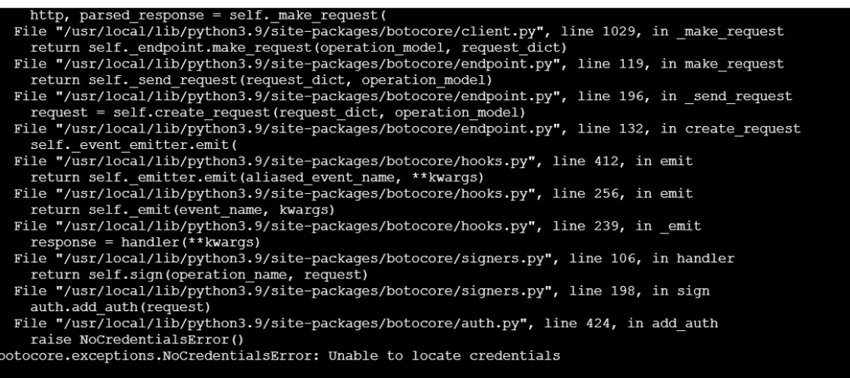

1. I faced few errors which are related to permission errors due to incorrect credentials mentioned in the application level.